**Testing Document Assignment 2**

**TEST 1: Testing user input**

**Purpose/Objective:** The purpose of this test is to ensure that the user is unable to input an invalid number of files to parse through.

**Test Configuration:** Run the program ‘UserInput.exe’ and try to input an alphanumeric number of files or a value less than or equal to 1.

**Expected Results:**

Prompts the user to try again both times informing them that their entry is invalid. Once a valid entry is entered, the program runs.

**Actual Results:** A capture of the output (i.e., actual results) of the program.

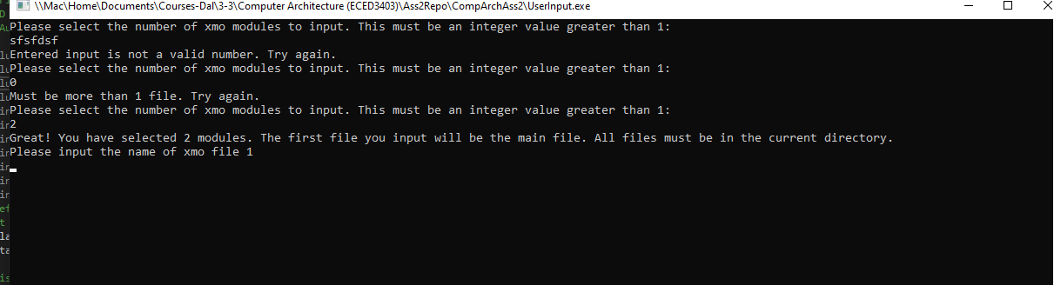

**Pass/Fail:** Pass

**TEST 2: A table of public symbols and their addresses is generated**

**Purpose/Objective:** The purpose of this test is to ensure that a table of public symbols and addresses are successfully generated. Files without publics should return a diagnostic on the screen.

**Test Configuration:** Run the UserInput.exe file and input the following xmo files:

**L1.xmo, which contains:**

S00900004C312E61736D0A

L0 Subr 0000

S1050100016890

L301020000

S1050104094CA0

S9030100FB

**L1P.xmo,** which contains:

S00A00004C31502E61736DB9

L1 Subr 0000

S107000099402F4CA4

S9030000FC

**Expected Results:** A symbol table containing the publics is created. Only one public should be found in the symbol table since there is only 1 L1 record found. A ‘No Publics Found’ should appear for the module without an L1 record.

**Actual Results:** A capture of the output (i.e., actual results) of the program.

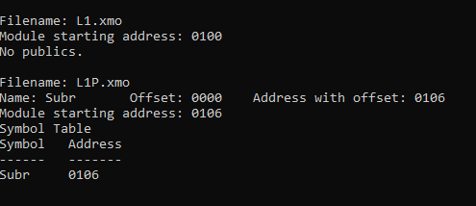

**Pass/Fail:** Pass

**TEST 3: Is the address of each public symbol correct?**

**Purpose/Objective:** The purpose of this test is to ensure that the address for each public symbol is correct. In this test, we will also be checking to ensure that the starting address of each file is correct.

**Test Configuration:** The same input files are utilizes as TEST 2. Uncomment the definition DEBUG in ReadFile.c. Recompile to view the debugging statements, which should show the addresses of each location.

**Expected Results:**

L1.xmo:

* S0 ignored
* L0 is ignored
* S1 value returns an address of 0102 (0100+2 bytes) for the relocation address. Starting address should be 0100 as seen in the S1 record.
* L3 ignored
* S1 returns 0106 for relocation address (2 bytes + starting address of 0104)
* Ignore S9 record

L1P.xmo:

* Starting address should be 0106 as per the previous module
* S0 ignored
* L1 printed with the offset (0000) and the address + the offset (0106)
* S1 ignored
* S9 ignored

**Actual Results:** A capture of the output (i.e., actual results) of the program.

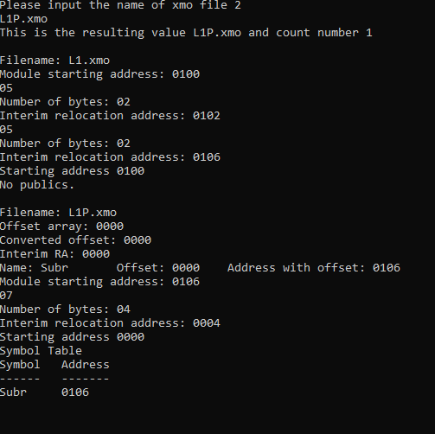

**Pass/Fail:** Pass